Examine the characteristics of the tundra environment that make it extreme. [22]
This essay can be matched with the following focus boxes in U4:
- 4.2.6 The Arctic tundra biome

A comparable essay would not be set as ‘examine’ is not a U4 command.
This essay contains references to alpine tundra, which would not feature in a U4 essay, but is credited for illustrative purposes.
During the course of this essay I will be examining the characteristics of the tundra environment that make it extreme. "Extreme" can be defined as "of a high or to the highest degree". There are many characteristics that make the tundra extreme, and these can be segregated into the abiotic features – climate and soil and the biotic features: plants and animals. I will be examining the Arctic and Alpine tundra, and will use case study knowledge to assist my response. I will use Verkhoyansk, East Russia as an example of Arctic tundra, and Niwot Ridge, Colorado as an example of Alpine tundra. Although the characteristics of the tundra interlink to make it extreme, I will use an element of criticality in my response in order to comment upon the significance of each.
To begin, I will assess the climatic features of the Arctic tundra. The Arctic tundra is a cold, treeless region found 60ºN between the polar ice cap and the coniferous forest (taiga). Verkhoyansk, Eastern Russia suffers an extremely cold, harsh climate, with strong winds and little precipitation with temperatures below freezing for 7 months of the year, often reaching below -50ºC. It is characterised by short summers, as there is a limited period of time when the sun rises above the horizon. There is a high albedo in the region, because the frozen surface reflects the little solar radiation back into the atmosphere, increasing positive feedback, and the lack of dark vegetation means the ground is unable to be warmed by the absorption of radiation from the sun.

Due to the extreme climate of Verkhoyansk, only an extreme type of soil can exist. Arctic soil is often cold, frozen and waterlogged. Permafrost underlies 24% of the earth's surface in total, 50% of Russia and 82% of Alaska. The following diagram will demonstrate how the tundra creates an inhospitable climate for plants:
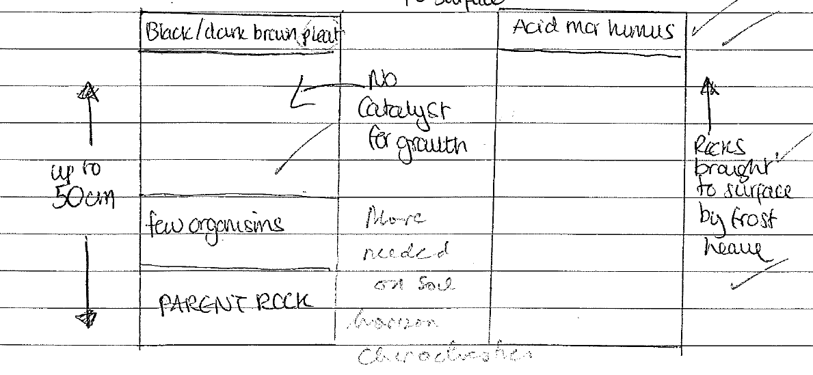
Due to the extreme kind of soil found in the Arctic tundra, a limited amount of plants can be sustained in this inhospitable climate, as there is no catalyst for growth. As a result the Arctic tundra lacks diversity and has a NPP of just 250g/m².
Due to the abbreviated growing season of the Arctic tundra, many plants are able to grow, flower and set within 6 weeks. Some plants are also capable of creating their own micro climates in the way they grow; this is the case with the cotton/tussock grass. I will now annotate a diagram of this species of plant below to demonstrate how it thrives under such harsh conditions:
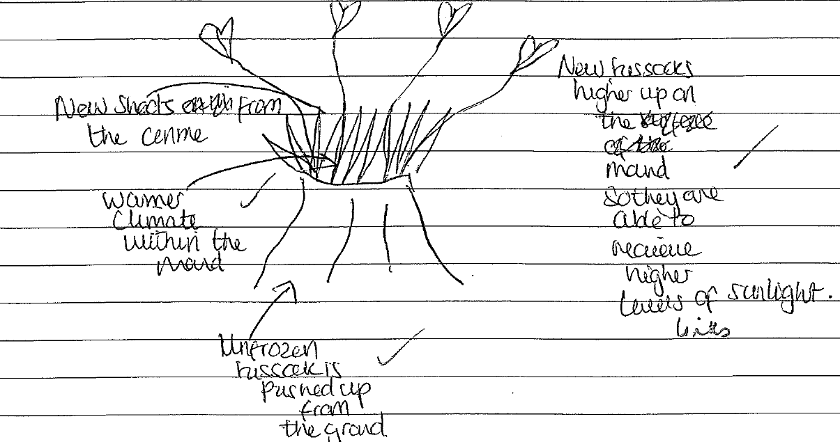
Due to the limited plant species of the arctic tundra, the ecosystem also lacks diversity, and because of this it is extremely fragile, meaning it is unable to recover quickly from change. In the short summer months, when the ground slowly thaws, millions of insects emerge and these provide food for many of the breeding birds. The Canadian arctic is home to around 100 species of bird, The Artic Tern being the most populous. Other animals of the Arctic tundra include the Arctic fox, lemmings and marmots who burrow to keep warm in the extreme conditions. There are also larger mammals which can be found in the arctic, as the diagram of the Caribou demonstrates:

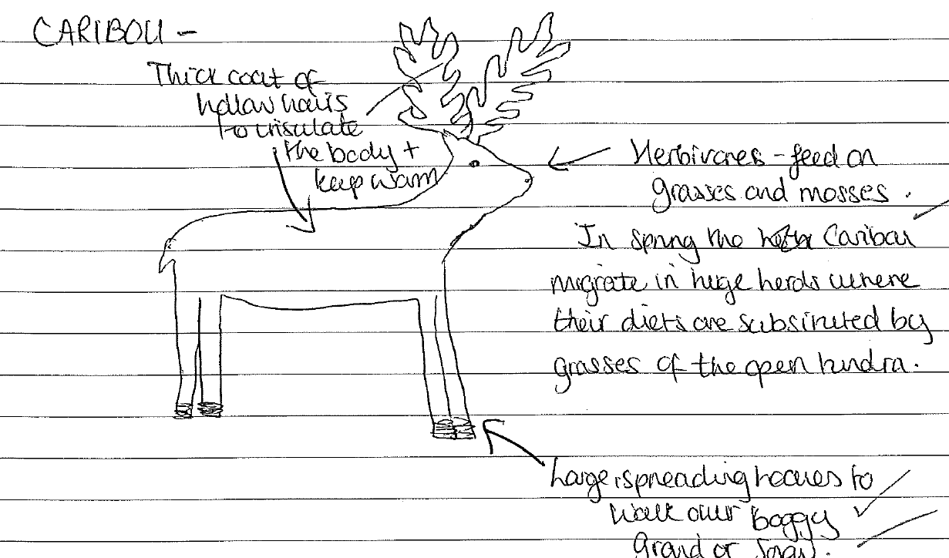

In conclusion, I believe that the climate of the arctic tundra stands out as being the most prominent characteristic. I think this because without the strong winds, long, dark winters and freezing temperatures, there would be nothing for the soil and biotic characteristics to adapt to.
I will now go on to examine the characteristics of the Alpine tundra. The Alpine tundra is extremely similar to the Arctic tundra in many ways; after all they are directly related. However, they differ in the way that the Alpine tundra biome resides in areas other than the Arctic and Polar Regions, and it also differs in the way that it is at altitude.
The climate of the Alpine tundra is very similar to that of the Arctic, however, it receives higher levels of sunlight due to being at altitude and thereby does not suffer such long periods of darkness, however, it is still characterised by abbreviated growing seasons. Niwot Ridge, near Denver in Colorado USA is an example of the Alpine tundra. It is 3252m in length and has high wind speeds which reach up to 170 miles per hour in some instances. It has a warmest temperature of about 8.2⁰C (July) and a coolest temperature of about -23⁰C (January). Although not quite as cold as the Arctic, it is apparent that the Alpine tundra still suffers a very unique and extreme environment, which thereby creates an extreme type of soil. The soil of the Alpine tundra compares to that of the Arctic, cold, frozen and waterlogged with high levels of permafrost. 1/3 of permafrost in the Alpine tundra leaves the system as evapotranspiration, meaning the remainder leaves as surface run-off. Although the Alpine tundra differs in the way that it has more horizons due to being at altitude, it still creates an inhospitable climate for plants, as, like the Arctic, there is no catalyst for growth.
Due to the extremity of the Alpine soil, plant diversity is limited. There are only around 200-300 species of plant in the Alpine tundra, which differs to the thriving diversity of biomes such as the tropical rainforest, which have around 500 species of trees and plant per m². The plants of the Alpine tundra have learnt to adapt to their surroundings – they have dense hairs which offer protection from the cool temperatures, and many have red pigments which absorb the sun's radiation and convert it into heat to offer warmth. Although trees are unable to be sustained, there are dwarf species of birch and willow, and many other cushion species which lie inches below the harsh winds.
Due to the limited plant variation, there is also a limited ecosystem. The animal species of the Alpine tundra are much like the animals of the Artic. The marmot is one of the most populous animals of the Alpine tundra, and the diagram below demonstrates how it is superbly adapted to the harsh conditions:
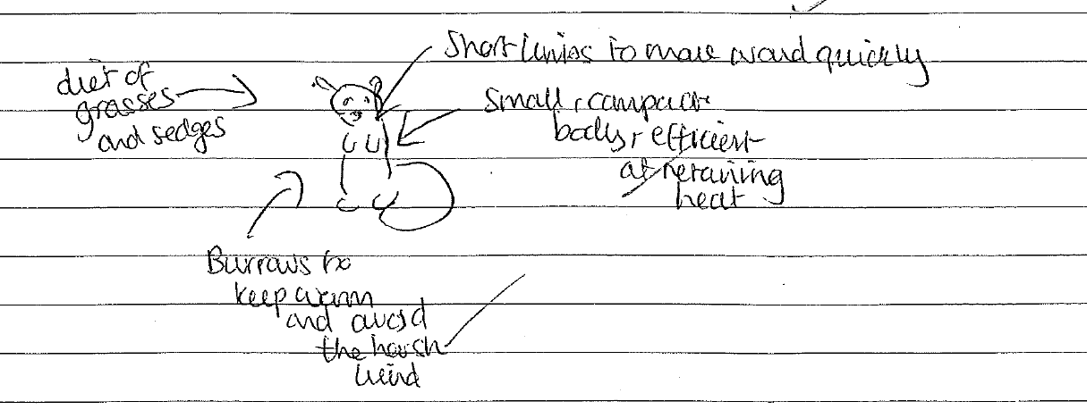

In conclusion I think that the most significant characteristic of the Arctic and Alpine tundra is the climate, as without the harsh wind speeds, freezing temperatures and limited moisture, neither the Artic or Alpine would have the soil, plants and animals it has today, as there would be nothing for them to adapt to. However, I can appreciate that each characteristic of the Arctic and Alpine tundra plays an important role in making both extreme environments, as all three interlink and intertwine with each other.
Examiner Commentary:
AO1 (8/9)
Wide ranging, thorough and accurate knowledge, high order of conceptual understanding
Evidence – detailed knowledge with a sound appreciation and definition of the concept of ‘extreme’. Comparison with tropical rainforest biome. Supporting climate, NPP statistics and locational detail
Wholly appropriate, accurate and well-developed examples

Evidence –Verkhoyansk, East Russia. Niwot Ridge, Colorado

Accurate and relevant supporting geographical terminology

Evidence – albedo, NPP, mor humus, evapotranspiration, surface runoff
Well-directed and well-annotated sketch maps/diagrams
Evidence – annotated climograph, annotated diagrams of soil, flora and fauna

AO2 (10/11)
Sophisticated application either to analyse or interpret or evaluate
Evidence – discursive from the start, with the discussion sustained
Synthesis of the connections between different elements of the response to the question
Evidence – linkages between climate, soils, flora and fauna maintained throughout
Confident application of the specialised concepts
Evidence –causality (limited solar insolation, linkage between climate and soil, flora and fauna but more partial for soil), feedback (reflection of solar radiation), mitigation and adaptation (adaptation of flora and fauna to extreme conditions)

AO3 (2/2)
A well-constructed, coherent and logical response
Evidence – well-structured (climate, soils, flora and fauna, taking arctic tundra first) answer with a very good standard of spelling, punctuation and grammar

