


GCSE (9-1)
ENGLISH
LANGUAGE
J351

For first teach in 2015
www.ocr.org.uk/englishlanguage

Student revision checklist
Version 1

Revision checklists

The tables below can be used as a revision checklist.
For more information please see the OCR GCSE English Language specification.
The table headings are explained below:

Assessable learning outcomes  You will be required to: | R | A | G | Comments
Here is a list of the learning outcomes for this qualification and the content you need to cover and work on. | You can use the tick boxes to show when you have revised an item and how confident you feel about it.  R = RED means you are really unsure and lack confidence; you might want to focus your revision here and possibly talk to your teacher for help.  A = AMBER means you are reasonably confident but need some extra practice.  G = GREEN means you are very confident.  As your revision progresses, you can concentrate on the RED and AMBER items in order to turn them into GREEN items.  You might find it helpful to highlight each topic in red, orange or green to help you prioritise. |  |  | You can use the comments column to:  - add more information about the details for each point  - add formulae or notes  - include a reference to a useful resource  - highlight areas of difficulty or things that you need to talk to your teacher about or look up in a textbook.

Component 01 Communicating information and ideas
Section A Reading information and ideas
Type of unseen text | Content | When looking at non-fiction texts, I can: | R | A | G | Comments
Two non-fiction from the 19th, 20th and 21st centuries  One text will always be drawn from the 19th century. | Students read and understand a wide range of non-fiction texts from the 19th to 21st centuries. For example, articles, travel writing, speeches and biographical writing.  Students read texts that are designed to persuade, inform, instruct or advise. | Identify and interpret key ideas and information from texts.
 |  | Give and explain the key points of a text to show that I have understood what I’ve read.
 |  | Identify similarities in the content of two texts.
 |  | Summarise ideas and information in texts.
 |  | Select quotations to support the points I have identified

Component 01 Communicating information and ideas
Section A Reading information and ideas
Type of unseen text | Content | When looking at non-fiction texts, I can: | R | A | G | Comments
Two non-fiction from the 19th, 20th and 21st centuries  One text will always be drawn from the 19th century | Students analyse how language and structure inform and impact on their reading of non-fiction texts.  Students have knowledge and understanding of linguistic terminology and structural features, in order to support their views about non-fiction texts. | Explain and illustrate how the writer’s choice of language shapes meaning.
 |  | Analyse how the writer uses language and structure to create effects and impact.
 |  | Use relevant subject terminology accurately to support my views.
 |  | Refer closely to the text by providing quotes or textual references to support the points I make.

Component 01 Communicating information and ideas
Section A Reading information and ideas
Type of unseen text | Content | When looking at non-fiction texts, I can: | R | A | G | Comments
Two non-fiction from the 19th, 20th and 21st centuries  One text will always be drawn from the 19th century | Students develop their skills to compare texts, looking at the ideas, and the ways these ideas are presented, in two texts.  Students develop their skills to evaluate the ideas, attitudes and values presented in two texts in relation to a specific theme or topic. | Make connections across two texts looking at the ideas, attitudes and values presented in them.
 |  | Use the form or genre help me understand how different texts present ideas.
 |  | Evaluate the impact or effect of texts on the reader.
 |  | Use and integrate quotations from two texts in a response.

Component 01 Communicating information and ideas
Section B Writing for audience, impact and purpose
Task | Content | When producing non-fiction writing, I can: | R | A | G | Comments
Produce pieces of non-fiction writing in different forms and for different audiences and purposes. | Students produce non-fiction writing, including writing to:  - describe  - explain  - inform  - instruct  - argue  - persuade.  Students develop skills to adapt their writing for different purposes, audiences and contexts.  Students can use vocabulary and grammatical features to achieve particular effects.  Students write with accurate spelling, grammar and punctuation | Organise ideas and information clearly.
 |  | Structure my writing so that it is clear and the order of points/ ideas makes sense. |  |  |  | Try to avoid repetition of the same points/ideas.
 |  | Select and emphasise key ideas and information to influence readers and reflect the purpose of the writing.
 |  | Maintain a consistent viewpoint across a non-fiction piece of writing.
 |  | Choose vocabulary and grammatical structures and features carefully to reflect the audience and the purpose of the writing.
 |  | Use language and structure to have an emotional impact.
 |  | Use a tone, style and register that is appropriate for the audience and the purpose of the writing.
 |  | Use a range of sentence structures.
 |  | Use accurate punctuation and spelling.

Component 02 Exploring effects and impact
Section A Reading meaning and effects
Type of unseen text | Content | When looking at literary texts, I can: | R | A | G | Comments
Two literary texts from the 20th and 21st centuries. | Students read and understand a wide range of literary texts from the 20th and 21st centuries. For example, extracts from novels, short stories or literary non-fiction such as autobiography.  . | Identify and interpret key ideas and information from texts.
Two literary texts from the 20th and 21st centuries. |  | Give and explain the key points of a text to show that I have understood what I’ve read.  .
Two literary texts from the 20th and 21st centuries. |  | Identify similarities in the content of two texts.
Two literary texts from the 20th and 21st centuries. |  | Summarise ideas and information in texts.
Two literary texts from the 20th and 21st centuries. |  | Select quotations to support the points I have identified.

Component 02 Exploring effects and impact
Section A Reading meaning and effects
Type of unseen text | Content | When looking at literary texts, I can: | R | A | G | Comments
Two literary texts from the 20th and 21st centuries | Students analyse how language and structure inform and impact on their reading of literary texts.  Students have knowledge and understanding of linguistic terminology and structural features, in order to support their views about literary texts. | Explain and illustrate how the writer’s choice of language shapes meaning.
Two literary texts from the 20th and 21st centuries |  | Analyse how the writer uses language and structure to create effects and impact.
Two literary texts from the 20th and 21st centuries |  | Use relevant subject terminology accurately to support my views.
Two literary texts from the 20th and 21st centuries |  | Refer closely to the text by providing quotes or textual references to support the points I make.

Component 02 Exploring effects and impact
Section A Reading meaning and effects
Type of unseen text | Content | When looking at literary texts, I can: | R | A | G | Comments
Two literary texts from the 20th and 21st centuries. | Students develop their skills to compare texts, looking at the ideas, and the ways these ideas are presented, in two texts.  Students develop their skills to evaluate the ideas, attitudes and values presented in two texts in relation to a specific theme or topic. | Make connections across two texts looking at the ideas, attitudes and values presented in them.
Two literary texts from the 20th and 21st centuries. |  | Use the form or genre help me understand how different texts present ideas.
Two literary texts from the 20th and 21st centuries. |  | Evaluate the impact or effect of texts on the reader.
Two literary texts from the 20th and 21st centuries. |  | Use and integrate quotations from two texts in a response.

Component 02 Exploring effects and impact
Section B Writing imaginatively and creatively
Task | Content | When producing non-fiction writing, I can: | R | A | G | Comments
Produce pieces of creative writing. | Students produce imaginative, original writing in a range of forms, including, for example, short stories and autobiographical writing.  Students develop skills to adapt their writing for different audiences and contexts.  Students can use vocabulary and grammatical features to achieve particular effects.  Students write with accurate spelling, grammar and punctuation. | Organise ideas clearly.
Produce pieces of creative writing. |  | Structure my writing so that it is clear and the order of ideas makes sense. |  |  |  | Try to avoid repetition of the same ideas.
Produce pieces of creative writing. |  | Select and emphasise key ideas to create effects and impact for readers.
Produce pieces of creative writing. |  | Maintain a consistent viewpoint across a piece of creative writing.
Produce pieces of creative writing. |  | Choose vocabulary and grammatical structures and features for effect.
Produce pieces of creative writing. |  | Use language and structure to have an emotional impact.
Produce pieces of creative writing. |  | Use a tone, style and register that is appropriate for the purpose of the writing.
Produce pieces of creative writing. |  | Use a range of sentence structures.
Produce pieces of creative writing. |  | Use accurate punctuation and spelling.

Component 03 or 04 Spoken Language endorsement
Task | Content | Students should be able to: | R | A | G | Comments
One spoken presentation in front on an audience. | Students plan and organise a spoken presentation. They identify the subject for their presentation in advance.  Students give a prepared spoken presentation to an audience which must include the teacher.  Presentations may take a wide variety of forms, including talks, debates, speeches and dialogues. | Select information and ideas for prepared spoken presentations.
One spoken presentation in front on an audience. |  | Organise information and ideas effectively and persuasively.
One spoken presentation in front on an audience. |  | Presenting information and ideas.
One spoken presentation in front on an audience. |  | Give presentations in a formal setting.
One spoken presentation in front on an audience. |  | Listen carefully to questions and feedback and respond appropriately.

 | As part of, or following, the presentation, Students must listen to and respond appropriately to questions and feedback. | Express ideas effectively using spoken Standard English.

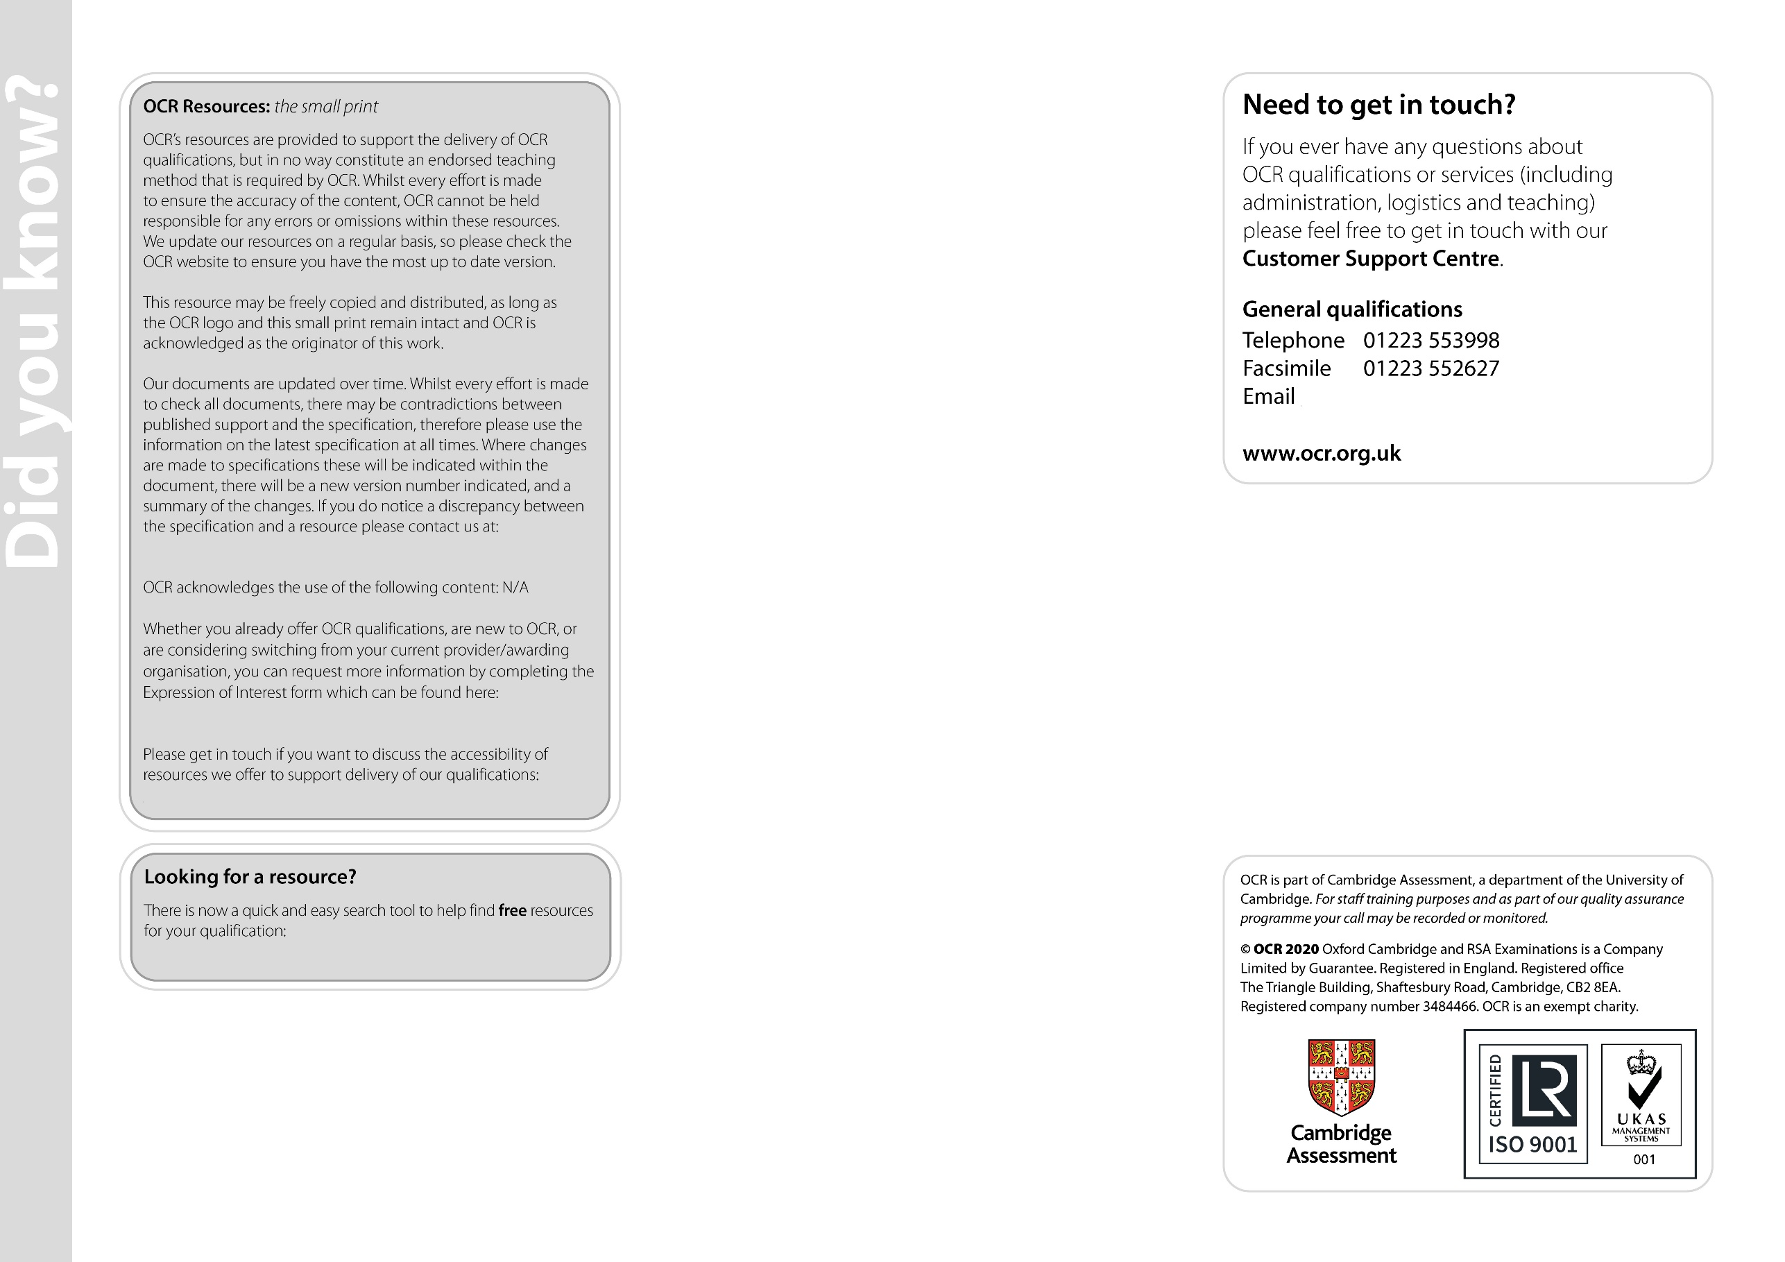
www.ocr.org.uk/i-want-to/find-resources/

resources.feedback@ocr.org.uk

www.ocr.org.uk/expression-of-interest

resources.feedback@ocr.org.uk

general.qualifications@ocr.org.uk

