Account for either seasonal variations or periodic changes in climate. [22]
This essay can me matched with the following focus boxes in U4
- 4.5.2 World's major climate types (seasonal variations)
- 4.5.4 Extreme weather events
A comparable essay would not be set as ‘account for’ is not a U4 command.
Seasonal variations in climate occur because of the formation of the global circulation model and the axes tilt of the earth causing seasonal shifts in the cell model. These then have knock on effects on jet streams, air masses and ocean currents which in turn cause seasonal variations in climate. I will first explain the global circulation model and then the knock on effects.
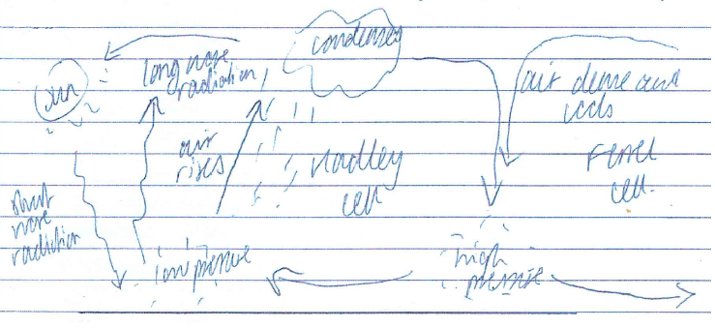
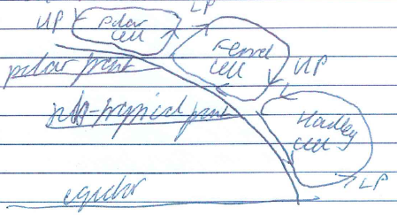
The sun gives insolation energy to the equator where the sun's rays are the most concentrated. This then leads to an energy surplus here where there is more insolation than radiation emmited from the heat of the earth. The global circulation model then balances out the heat to areas of deficit at higher latitudes where there is more radiation than insolation. Where the sun's rays are the strongest, the Intertropical Convergence Zone is formed where the heat of the earth from the sun's rays causes air to warm, become less dense and rise. As the air rises, it cools due to being further from the earth and also from the adiabatic lapse rate, as there is less pressure pushing down on the air as it rises, particles spread out and due to the low of concentration of energy, the air particles cool down. The cooling causes relative humidity to rise and when it reaches 100%, water vapour is turned into a liquid and precipitation is formed over this low pressure region. The air particles then are cooled and become more dense, which results in the air falling around the column of rising air; when the ITCZ is around the equator, this falling air is typically located around the tropics. This causes dry conditions here as there is little moisture in the air, the air is warmed when it reaches the ground creating low relative humidity and so there is little condensation. Winds then blow from high pressure to low pressure regions, and when winds blow away from the ITCZ they form the Ferrel Cell. Subsequently, the air rising on the Ferrel Cell can then form the Polar Cell as seen below:
Shifts in the global circulation model are caused by the 23.5 degree tilt of the axis of the earth.
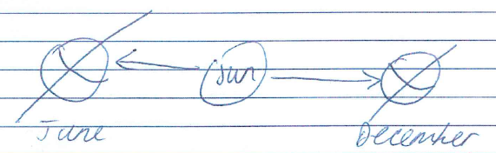
On the 21st of June in the Summer Solstice, the sun's energy is most concentrated on the Tropic of Cancer. On 21st of December in the Winter Solstice, the sun's energy is most focused on the Tropic of Capricorn. On 21st of March in the Spring Equinox and 22nd of October in the Autumn Equinox, the sun's energy is most focused on the equator. It is these shifts of where the sun's energy is most focused which determines the position of the ITCZ and in turn cause seasonal variations in climate.
One effect of the shifting cell model is that there are seasonal changes in precipitation levels. In a tropical region such as Lagos, Nigeria, shifts in the ITCZ bring heavy rain in May at 400mm and then when the ITCZ shifts to the southern hemisphere, there is less rain as the sub-tropical high pressure is located over the equatorial region bringing only 200mm of rain to Lagos from November–March.
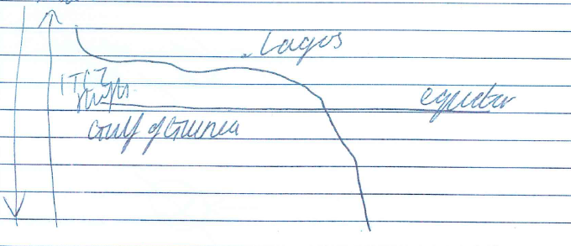
The position of Lagos by the sea also brings seasonal variations in climate. As the ITCZ first shifts over the Gulf of Guinea, it picks up moisture from the ocean. This in turn brings heavy rain to Nigeria of 400mm in May. When the ITCZ starts returning from the Tropic of Cancer after June 22nd and the ITCZ passes over Lagos for the second time in October, it brings less heavy rainfall of only 200mm.
Another seasonal variation in climate is to do with latitude and temperatures. In the UK, a temperate region, temperatures reach highs of 22˚C in July and lows of 4˚C in January. This is due to the sun's rays being more concentrated on the northern hemisphere in June than in January. However, the temperatures are also caused by proximity to the sea in this western maritime climate. The ocean has a low thermal inertia, heating up and cooling down more slowly than the land. This in turn causes the temperatures to be more mild than inland areas not effected by the ocean such as Moscow which has highs of 21˚C in June and lows of -5˚C in January which shows more extreme seasonal variations in temperature. It must also be noted that with higher latitudes, the sun's rays are less concentrated giving colder temperatures near the poles.

The seasonal variations in the jet stream; formed by the pressure differences between the cells forming fast moving winds flowing in Rossby Waves can give rise to seasonal variations in climate. The UK is effected by the Polar Front Jet Stream formed between the Ferrel and Polar Cells. When the jet stream passes south of the UK in winter as the global circulation model shifts south, typically this brings colder Polar Cell air from ther north over the UK bringing colder conditions. In the summer, the jet stream shifts north over the UK, typically bringing warmer Ferrel Cell air to the UK. It also depends on the direction of the Rossby Waves in which the jet stream moves. If the jet stream meanders towards the north pole it gains more speed due to a higher temperature gradient which makes the jet stream faster bringing more low pressure and rain, as air is pushed up. When the jet stream meanders southwards, the jet slows down causing air to fall bringing higher pressure to the UK. Typically, due to the cell shifts, fast jet streams occur in winter, like the UK floods in October 2013, and slower jet streams occur in summer such as in the August 2003 heatwave over Europe.
Another cause of seasonal variations is to do with air mass movements. An air mass is a body of air with similar characteristics. The UK typically exepriences a tropical maritime air mass from the Ferrel Cell air shifting north and the Coriolis effect, the path of the winds affected by the earth's spin, bringing the air from the south-west over the Atlantic. This usually forms mild but wet conditions. However, the UK can experience other air masses where air is shifted from the north east by the easterly winds in the Polar Cell coming south over the UK, also caused by the Coriolis effect.
Another seasonal variation is caused by ocean currents. The Coriolis effect, causing shifting wind patterns from the global circulation, causes surface ocean currents to change direction. Typically they flow clockwise in the northern hemisphere and anti-clockwise in the southern hemisphere. Montreal in Canada is effected by the cold Labrador current in winter. This brings temperatures of -5˚C in January. However, in the summer months, the wind directions change and the current is shifted further north which brings the warmer Gulf Stream into more influence around the East Coast of USA and Canada. This means, in summer, temperatures here are typically 20˚C due to the colder current moving north.
In conclusion, it is clear the main causes of seasonal variations in climate are due to the global circulation model formation and the tilt of the earth's axis causing seasonal shifts of the cells and the ITCZ and causing the sun's energy to be more concentrated over different points of the earth. It must also be noted that El Nino effects can occur temporarily over the Pacific Ocean. With teleconnections, this shifting direction of the Walker Cell can cause global changes. However, this may not be called "seasonal" as it lasts from 1-3 years and only occurs once every 5-8 years. Climate hazards such as tornadoes can also be more common in different seasons such as hurricanes are more common in the Northern Hemisphere in August and tornadoes are more common in April in the USA.
Examiner Commentary:
AO1 (9/9)
Wide ranging, thorough and accurate knowledge, high order of conceptual understanding
Evidence – thorough knowledge and understanding of the key factors which account for seasonal variations in climate;references to jet streams, air masses and ocean currents provide an indication of a high order of conceptual understanding; maritime and latitudinal influences on seasonality are explained with supporting locational detail and statistics

Wholly appropriate, accurate and well-developed examples
Evidence – Lagos, Nigeria; the UK; Labrador Current influence on eastern seaboard of Canada/US
Accurate and relevant supporting geographical terminology
Evidence –adiabatic; Hadley, Ferrel, Polar cells; solstice, equinox; thermal heat capacity; Rossby waves; temperature gradient; meanders; El Nino
A range of integrated sketch maps/diagrams
Evidence – global circulation, seasonal variations, location of Lagos in relation to equator
AO2 (11/11)
Sophisticated application either to analyse or interpret or evaluate

Evidence – application of knowledge and understanding of global circulation and other factors in an intelligent way to seasonal variations

Synthesis of the connections between different elements of the response to the question

Evidence –links between atmospheric circulation, maritime and latitudinal influences and seasonal variations for polar, temperate and tropical regions

Confident application of the specialised concepts

Evidence –causality (shift in position of overhead sun, latitudinal and maritime influences), systems (global atmospheric system)

AO3 (2/2)
A well-constructed, coherent and logical response

Evidence – well-structured answer with a good standard of spelling, punctuation and grammar

